Space Facts
All planets in the solar system orbit the sun, which is a star.
Scientists
Nicolaus Copernicus
Realised that the Sun is at the centre of our solar system
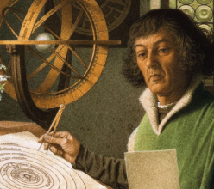
Our Solar System consists of the Sun, Mercury, Venus, Earth, Mars, Jupiter, Saturn, Uranus and Neptune. Pluto used to be counted as a planet, but it has now been reclassified as a dwarf planet.

All stars, planets and moons are spherical because of the way in which they form.

The Moon orbits the Earth. The gravitational pull of the Moon causes our oceans’ tides.
Day and night on Earth are caused by the rotation of Earth as it orbits the Sun.

Solar System Statistics
The largest planet in the Solar System is Jupiter. The smallest is Mercury.
It takes light 8 minutes and 20 seconds to travel from the Sun’s surface to Earth.
The Sun and the planets in our solar system were formed 4.5 billion years ago.
The Sun contains 99.86% of the Solar System's known mass.
The Earth orbits the Sun at 30 km per second.
The diameter of the sun is 1,391,000 km.
It takes Pluto 90,560 Earth days to orbit the sun.
A day on Mercury lasts for 4,222.6 hours.
Mercury and Venus have no moons but Jupiter has 79.

The Earth’s axis is tilted in relation to its orbit around the sun. This is why we have seasons.
Shadows are formed when an opaque object blocks the light from a light source
The phases of the moon are caused by the Earth’s shadow on the Moon’s surface
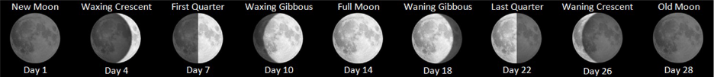
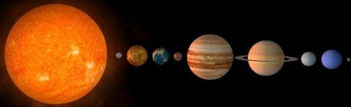

The nine planets of Our solar system The distance between the planets is much greater in reality.

Isaac Newton
Discovered the laws of motion and universal gravitation which explain planetary orbits, tides and the trajectories of comets.
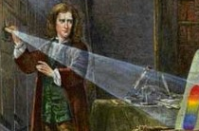
Galileo Galilei
Invented the first space telescope
Is know as the “father of modern science”
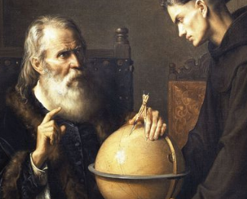

Key Vocabulary
Star A burning mass of gas that makes heat and light energy (E.g. the sun).
Planet An astronomical object that orbits a star and does not emit its own light. It can be terrestrial (dense and rocky) or Jovian (gas giant).
Gravity The force that attracts an object towards a larger object.
Solar System A star with objects (such as planets) revolving around it.
Light-year The distance light travels in a year (≈9.46 trillion KM or 9,460,000,000,000 KM).
Galaxy An extremely large group of stars and planets that extends over many billions of light-years, held together by gravity (E.g. Milky Way and Andromeda).
Universe All of space and everything in it (including stars, planets and galaxies).
Satellite An object either natural (E.g. a moon) or man-made, that orbits around a planet.
Orbit A curved path of a planet, satellite or spacecraft around an object such as the sun due to the attraction of gravity.
Vacuum A space containing no air or gas.
Asteroid Irregularly shaped rock that orbits the sun, mostly occurring in the asteroid belt.
Meteor A mass of rock that burns after entering the Earth’s atmosphere (meteorite when the rock has cooled on Earth).
Comet A mass of ice and dust that has a long, luminous tail of gas.
NASA The National Aeronautics and Space Administration – a US agency responsible for the exploration and study of space.
Astronomy The branch of science that deals with space and the physical universe as a whole.

